**ASSIGNMENT: 2**

* Connected to the Store Sales Data, cleaned the data. A text table shown below with sales in terms of customer name, product category and region:

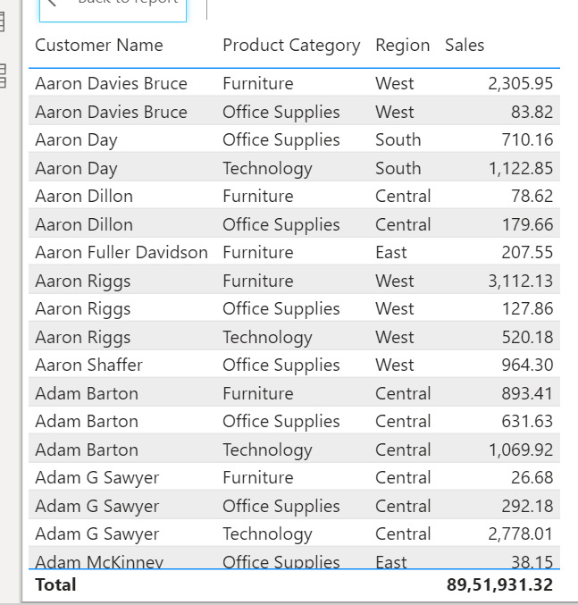

* California (highlighted in blue) has the highest sales in terms of technology which is approximately 1.2M:

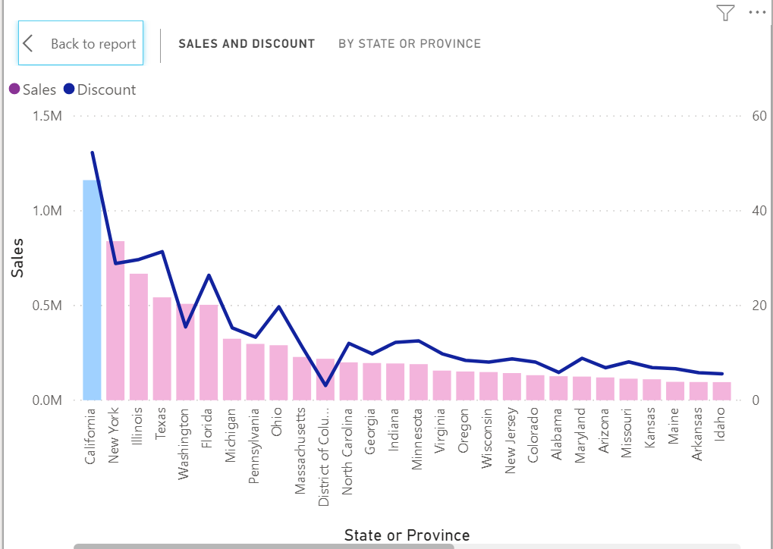

* Donut chart on sales by product category:

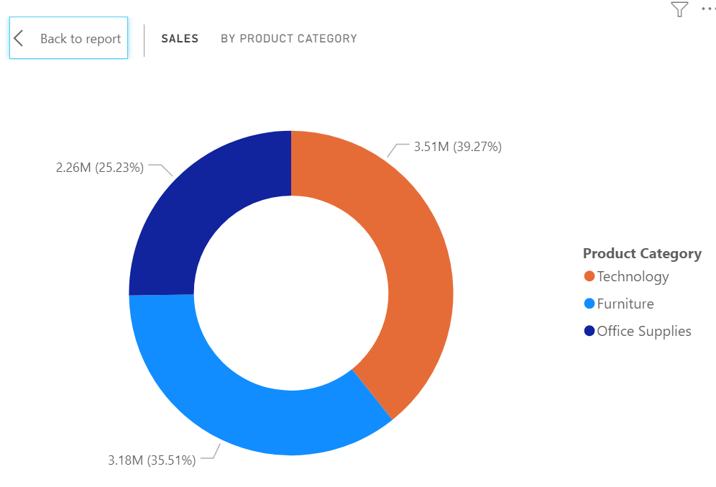

* Slicer that is showing the regions in dropdown:

